Neeraj Appari S073

Practical 19

Aim: Write C# program to swap two numbers using passing parameters by value.

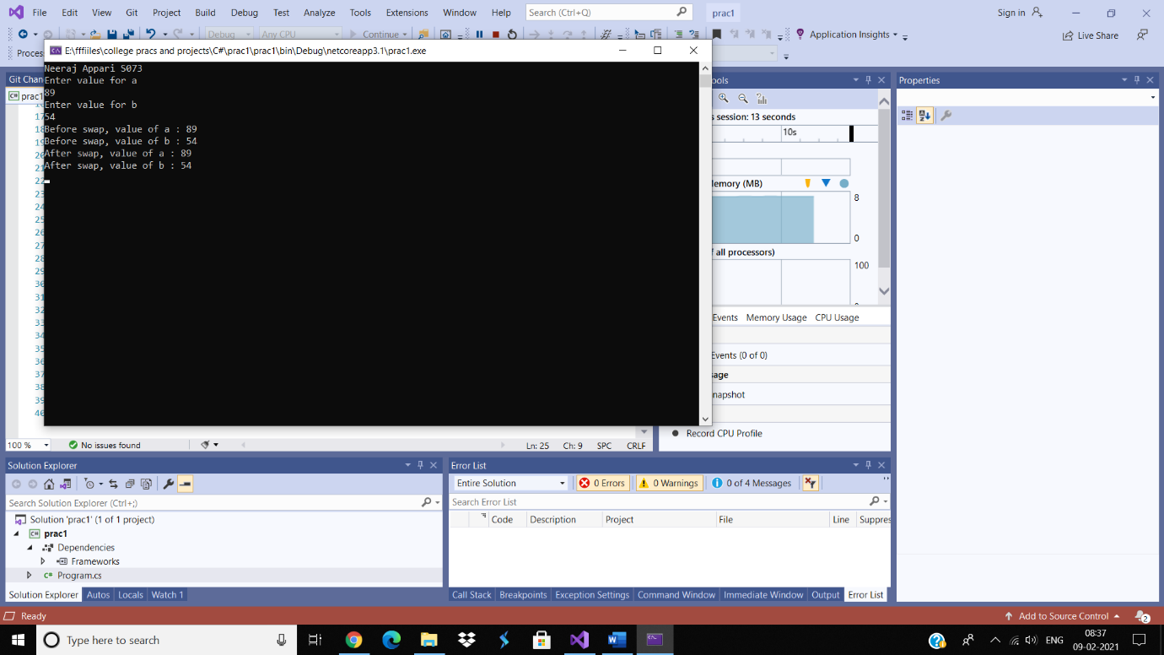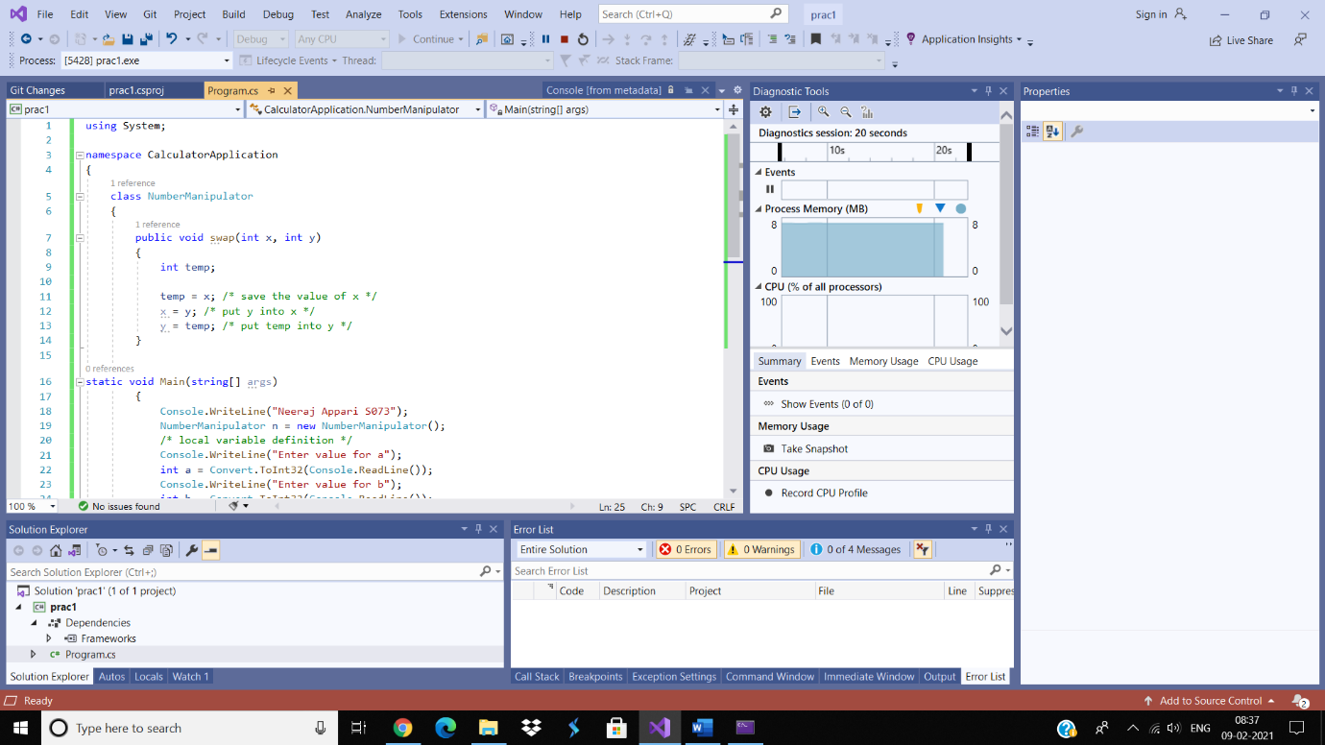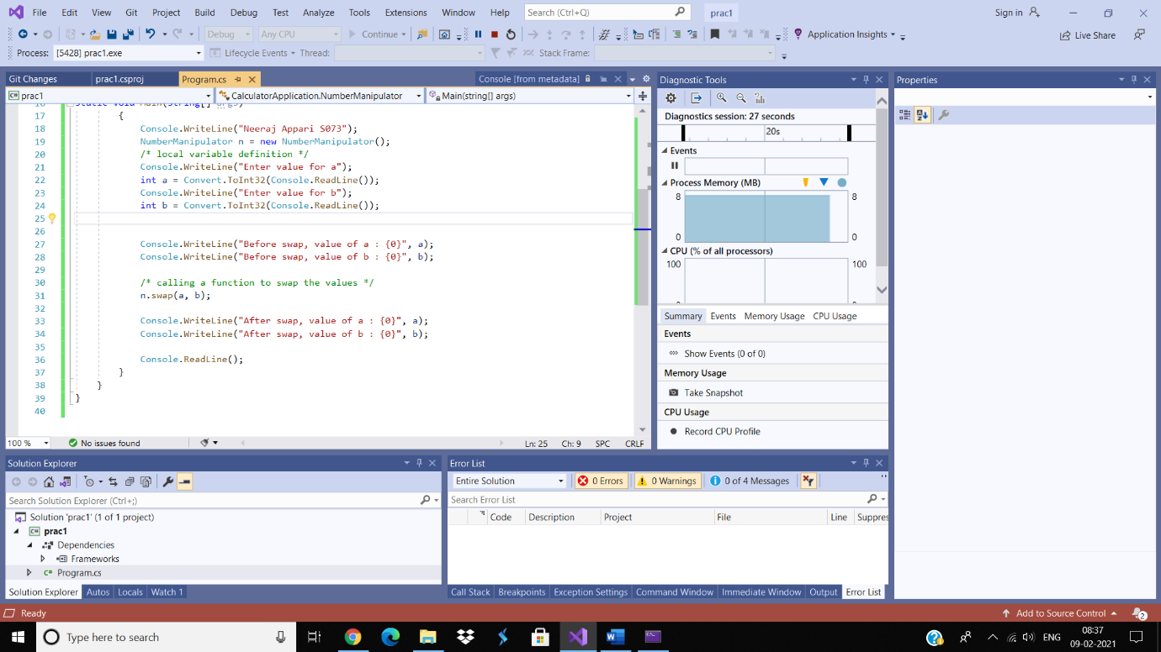

Practical 20

Aim: Write C# program to swap two numbers using passing parameters by reference.

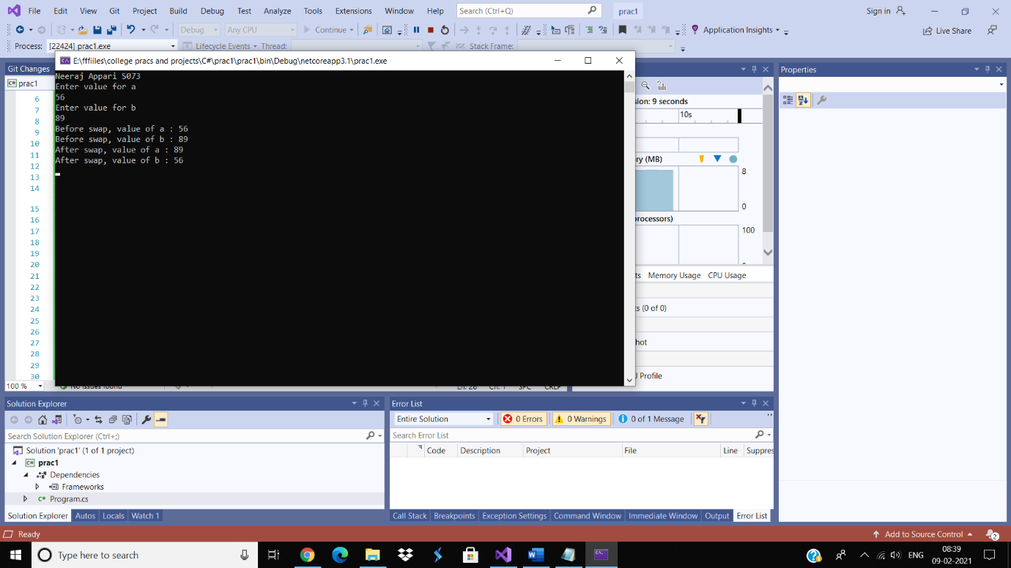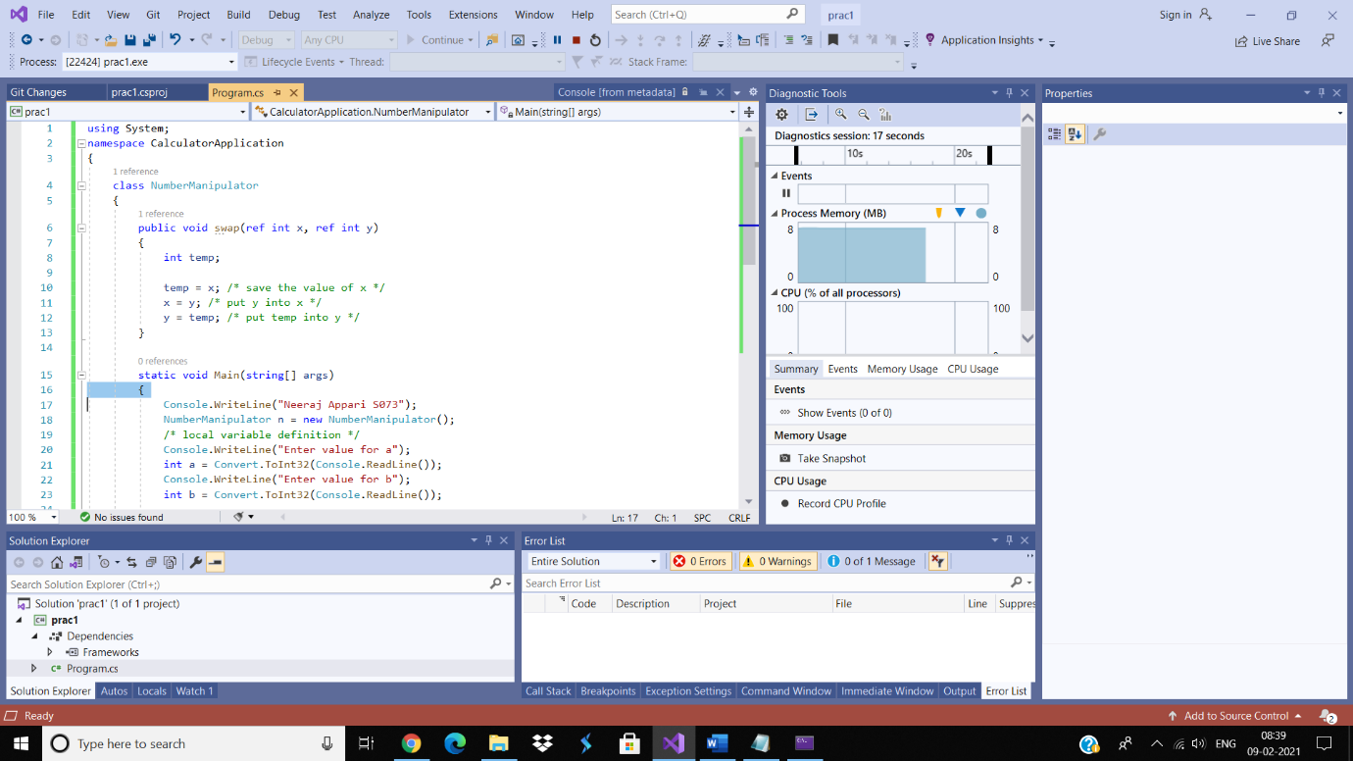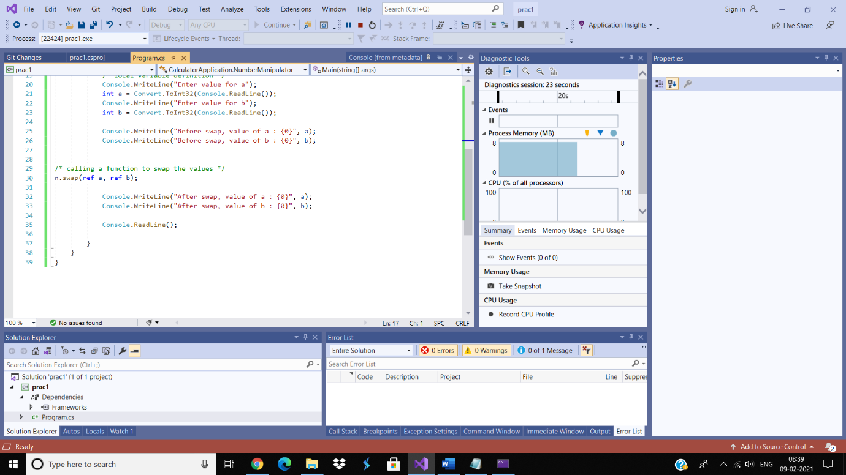

Practical 21

Aim: Write C# program to swap two numbers using passing parameters by output.

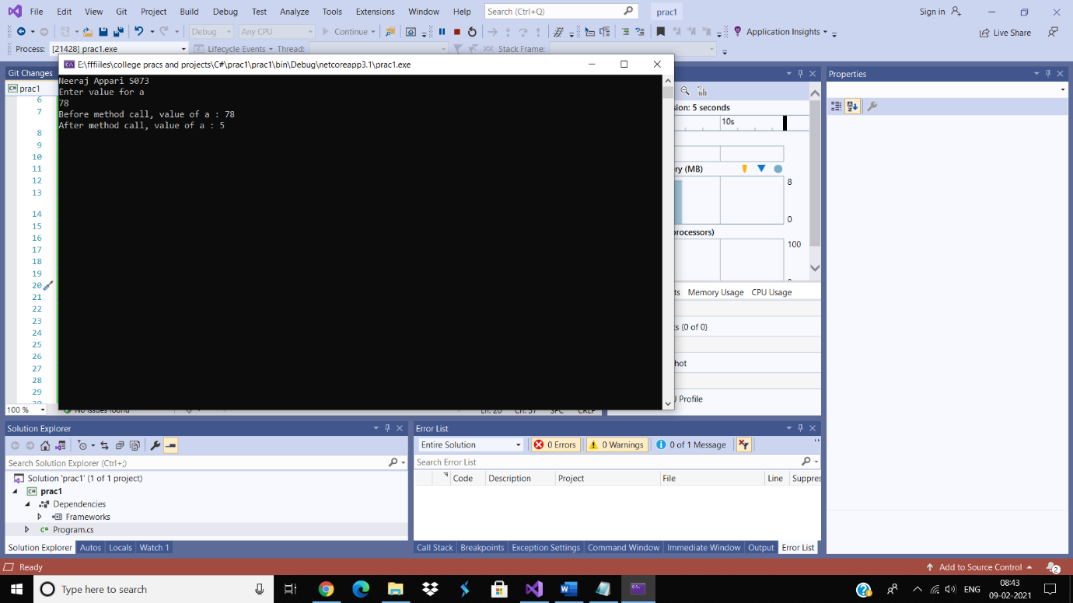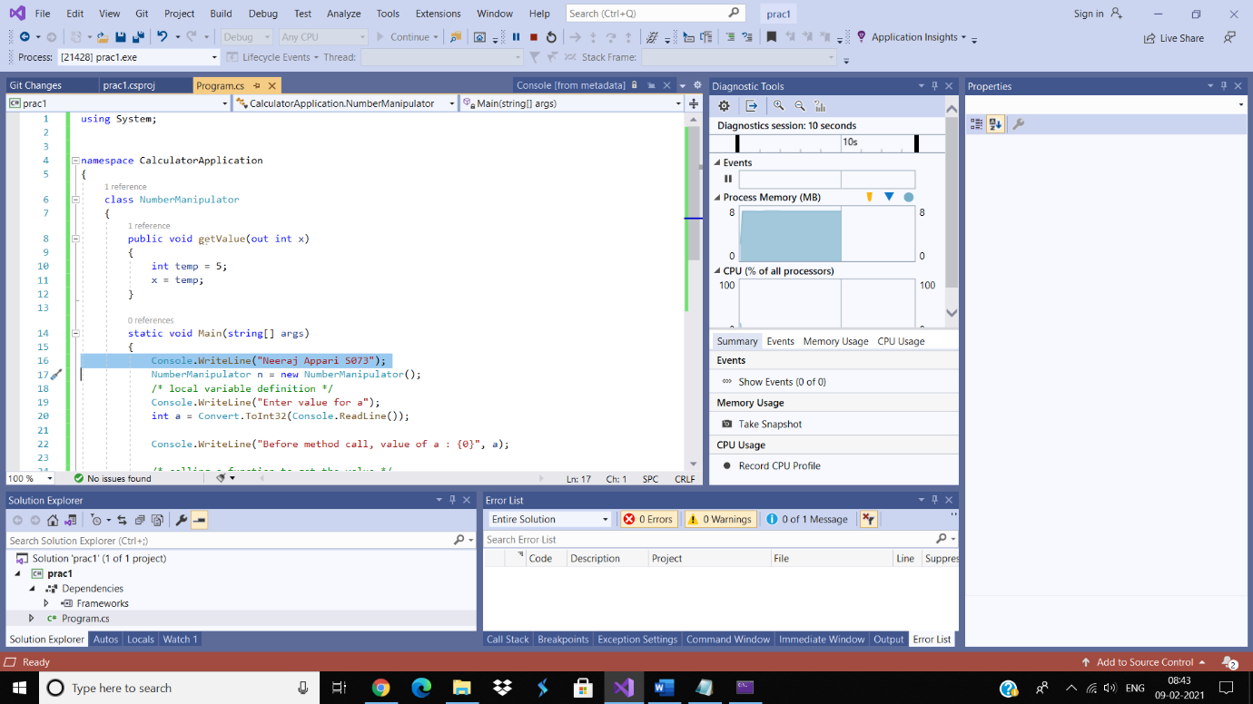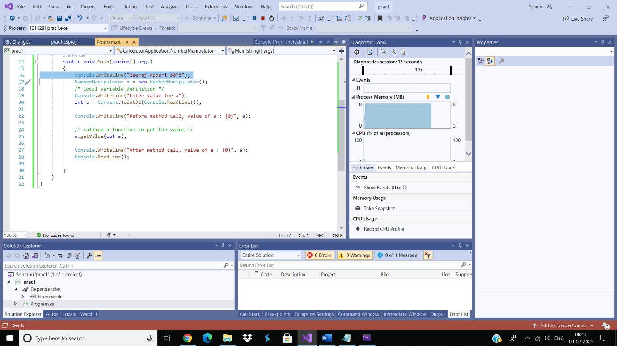

Practical 22

Aim: Write C# program to calculate area of rectangle using inheritance.

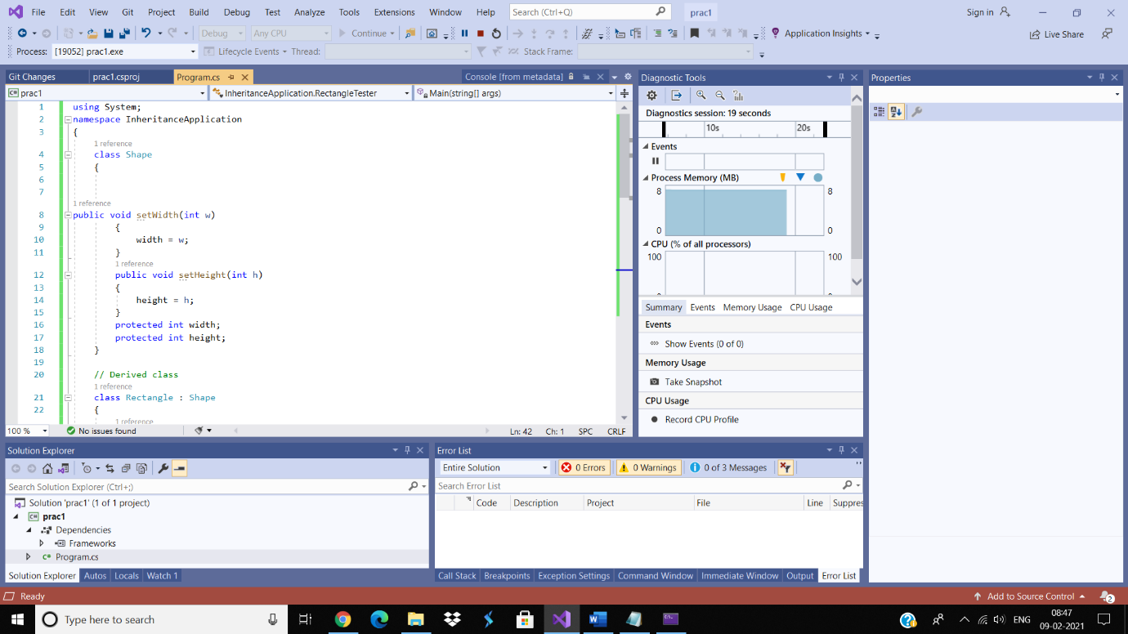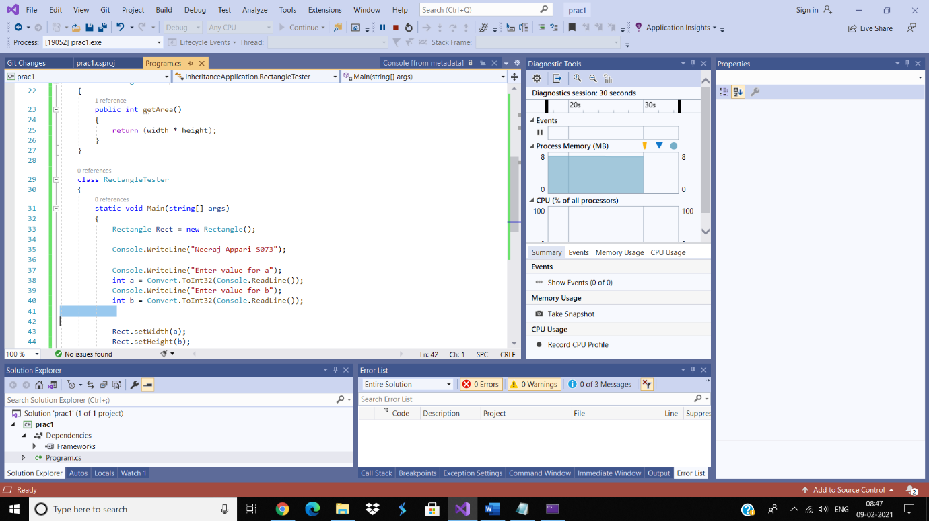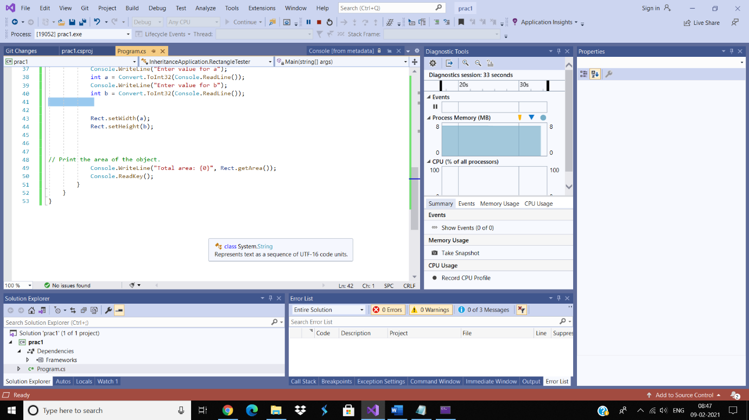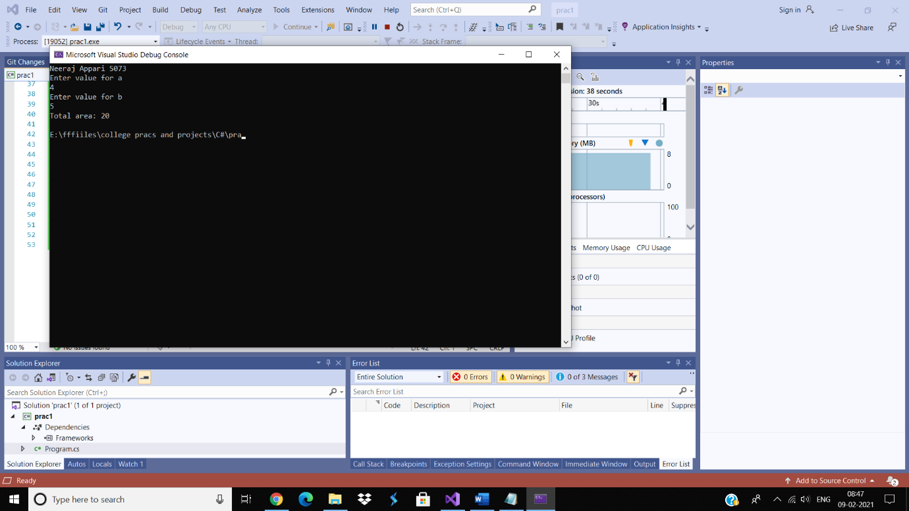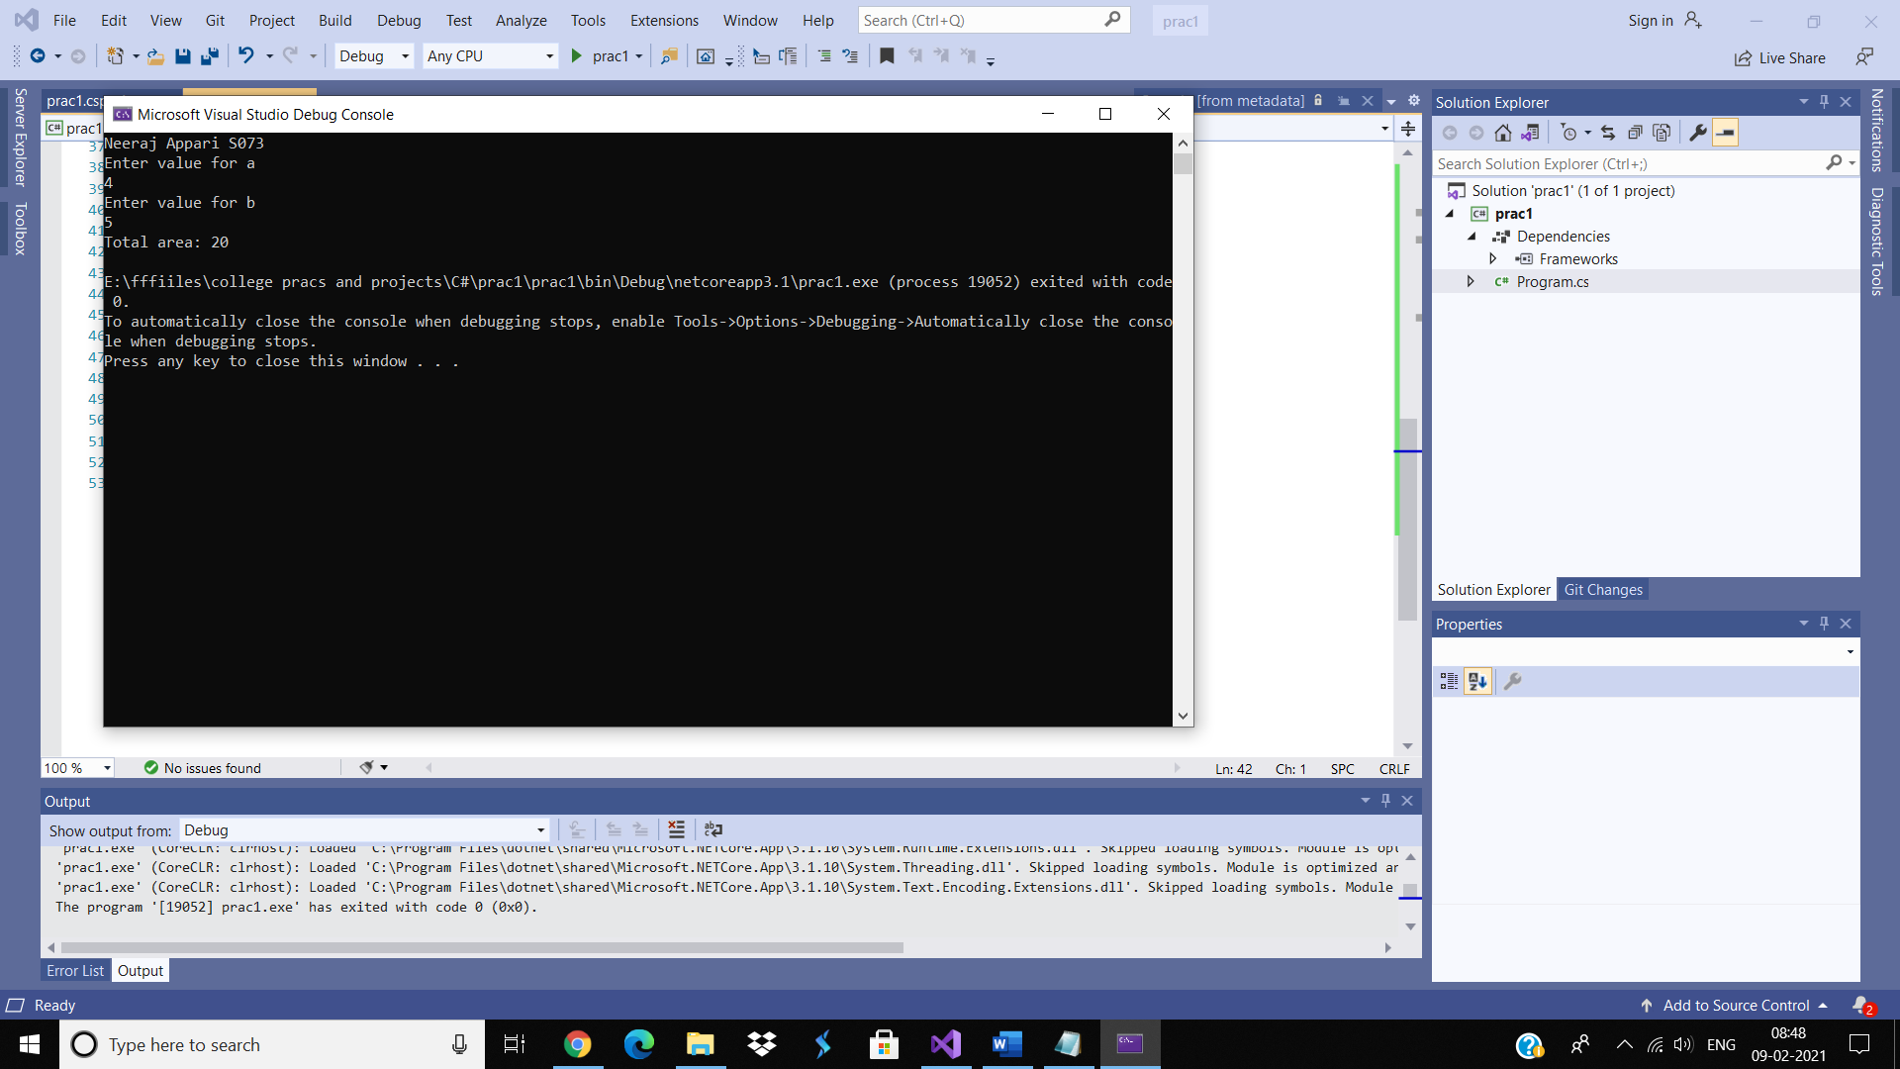

using System;

namespace CalculatorApplication

{

class NumberManipulator

{

public void swap(int x, int y)

{

int temp;

temp = x; /\* save the value of x \*/

x = y; /\* put y into x \*/

y = temp; /\* put temp into y \*/

}

static void Main(string[] args)

{

Console.WriteLine("Neeraj Appari S073");

NumberManipulator n = new NumberManipulator();

/\* local variable definition \*/

Console.WriteLine("Enter value for a");

int a = Convert.ToInt32(Console.ReadLine());

Console.WriteLine("Enter value for b");

int b = Convert.ToInt32(Console.ReadLine());

Console.WriteLine("Before swap, value of a : {0}", a);

Console.WriteLine("Before swap, value of b : {0}", b);

/\* calling a function to swap the values \*/

n.swap(a, b);

Console.WriteLine("After swap, value of a : {0}", a);

Console.WriteLine("After swap, value of b : {0}", b);

Console.ReadLine();

}

}

}

using System;

namespace CalculatorApplication

{

class NumberManipulator

{

public void swap(ref int x, ref int y)

{

int temp;

temp = x; /\* save the value of x \*/

x = y; /\* put y into x \*/

y = temp; /\* put temp into y \*/

}

static void Main(string[] args)

{

Console.WriteLine("Neeraj Appari S073");

NumberManipulator n = new NumberManipulator();

/\* local variable definition \*/

Console.WriteLine("Enter value for a");

int a = Convert.ToInt32(Console.ReadLine());

Console.WriteLine("Enter value for b");

int b = Convert.ToInt32(Console.ReadLine());

Console.WriteLine("Before swap, value of a : {0}", a);

Console.WriteLine("Before swap, value of b : {0}", b);

/\* calling a function to swap the values \*/

n.swap(ref a, ref b);

Console.WriteLine("After swap, value of a : {0}", a);

Console.WriteLine("After swap, value of b : {0}", b);

Console.ReadLine();

}

}

}

using System;

namespace CalculatorApplication

{

class NumberManipulator

{

public void getValue(out int x)

{

int temp = 5;

x = temp;

}

static void Main(string[] args)

{

Console.WriteLine("Neeraj Appari S073");

NumberManipulator n = new NumberManipulator();

/\* local variable definition \*/

Console.WriteLine("Enter value for a");

int a = Convert.ToInt32(Console.ReadLine());

Console.WriteLine("Before method call, value of a : {0}", a);

/\* calling a function to get the value \*/

n.getValue(out a);

Console.WriteLine("After method call, value of a : {0}", a);

Console.ReadLine();

}

}

}

using System;

namespace InheritanceApplication

{

class Shape

{

public void setWidth(int w)

{

width = w;

}

public void setHeight(int h)

{

height = h;

}

protected int width;

protected int height;

}

// Derived class

class Rectangle : Shape

{

public int getArea()

{

return (width \* height);

}

}

class RectangleTester

{

static void Main(string[] args)

{

Rectangle Rect = new Rectangle();

Console.WriteLine("Neeraj Appari S073");

Console.WriteLine("Enter value for a");

int a = Convert.ToInt32(Console.ReadLine());

Console.WriteLine("Enter value for b");

int b = Convert.ToInt32(Console.ReadLine());

Rect.setWidth(a);

Rect.setHeight(b);

// Print the area of the object.

Console.WriteLine("Total area: {0}", Rect.getArea());

Console.ReadKey();

}

}

}